Blockchain Exp - 3

Aim: Create a Cryptocurrency using Python and perform mining in the Blockchain created.

Theory:

1. Blockchain Overview
Blockchain is a distributed and decentralized ledger that stores information in a series of linked blocks.
Each block contains:
- Transaction data
- Timestamp
- Previous block’s hash
- Its own unique hash (digital fingerprint)
Once data is recorded in a blockchain, it becomes immutable because altering one block would require recalculating all subsequent blocks.

2. Mining
Mining is the process of:
- Collecting pending transactions into a block.
- Performing a computational puzzle (Proof-of-Work) to find a valid hash.
- Adding the new block to the blockchain.
Broadcasting it to all connected peers.
Miners are rewarded with cryptocurrency for successfully mining a block.

3. Multi-Node Blockchain Network
In this lab, we simulate three independent blockchain nodes (5001, 5002, 5003).
Each node:
- Runs on a separate port.
- Maintains its own copy of the blockchain.
- Can connect with peers to share and validate blocks.

4. Consensus Mechanism
We use the Longest Chain Rule:
- If multiple versions of the chain exist, the longest valid chain is chosen.
- This ensures all nodes agree on a single transaction history.

5. Transactions & Mining Reward
Each transaction has:
- Sender
- Receiver
- Amount
When mining a block:
- Pending transactions are added to the block.
- A reward transaction is added automatically to pay the miner.

6. Chain Replacement
When /replace_chain is called:
- Node requests chains from peers.
- If it finds a longer and valid chain, it replaces its own.
- This keeps the blockchain consistent across all nodes.

Tools & Libraries Used
- Python 3.x
- Flask – Web framework for API endpoints
pip install Flask
- Requests – For HTTP communication between nodes
pip install requests==2.18.4
- Postman – For testing API requests
- Python Standard Libraries:
  - datetime
  - jsonify
  - hashlib
  - uuid4
  - urlparse
  - request

Code :

# Module 2 - Create a Cryptocurrency

# To be installed:
# Flask==0.12.2: pip install Flask==0.12.2
# Postman HTTP Client: https://www.getpostman.com/
# requests==2.18.4: pip install requests==2.18.4

# Importing the libraries
import datetime
import hashlib
import json
from flask import Flask, jsonify, request
import requests
from uuid import uuid4 # Generate a unique id that is in hex
from urllib.parse import urlparse # To parse url of the nodes

# Part 1 - Building a Blockchain

class Blockchain:

def __init__(self):
self.chain = []
self.transactions = [] # Adding transactions before they are added to a block
self.create_block(proof = 1, previous_hash = '0')
self.nodes = set() # Set is used as there is no order to be maintained as the nodes can be from all around the globe

def create_block(self, proof, previous_hash):
block = {'index': len(self.chain) + 1,
'timestamp': str(datetime.datetime.now()),
'proof': proof,
'previous_hash': previous_hash,
'transactions': self.transactions} # Adding transactions to make the blockchain a cryptocurrency
self.transactions = [] # The list of transacction should become empty after they are added to a block
self.chain.append(block)
return block

def get_previous_block(self):
return self.chain[-1]

def proof_of_work(self, previous_proof):
new_proof = 1
check_proof = False
while check_proof is False:
hash_operation = hashlib.sha256(str(new_proof**2 - previous_proof**2).encode()).hexdigest()
if hash_operation[:4] == '0000':
check_proof = True
else:
new_proof += 1
return new_proof

def hash(self, block):
encoded_block = json.dumps(block, sort_keys = True).encode()
return hashlib.sha256(encoded_block).hexdigest()

def is_chain_valid(self, chain):
previous_block = chain[0]
block_index = 1
while block_index < len(chain):
block = chain[block_index]
if block['previous_hash'] != self.hash(previous_block):
return False
previous_proof = previous_block['proof']
proof = block['proof']
hash_operation = hashlib.sha256(str(proof**2 - previous_proof**2).encode()).hexdigest()
if hash_operation[:4] != '0000':
return False
previous_block = block
block_index += 1
return True

# This method will add the trqnsaction to the list of trnsactions
def add_transaction(self, sender, receiver, amount):
self.transactions.append({'sender': sender,
'receiver': receiver,
'amount': amount})
previous_block = self.get_previous_block()
return previous_block['index'] + 1 # It will return the block index to which the transaction should be added

# This function will add the node containing an address to the set of nodes created in init function
def add_node(self, address):
parsed_url = urlparse(address) # urlparse will parse the url from the address
self.nodes.add(parsed_url.netloc) # Add is used and not append as it's a set. Netloc will only return '127.0.0.1:5000'

# Consensus Protocol. This function will replace all the shorter chain with the longer chain in all the nodes on the network
def replace_chain(self):
network = self.nodes # network variable is the set of nodes all around the globe
longest_chain = None # It will hold the longest chain when we scan the network
max_length = len(self.chain) # This will hold the length of the chain held by the node that runs this function
for node in network:
response = requests.get(f'http://{node}/get_chain') # Use get chain method already created to get the length of the chain
if response.status_code == 200:
length = response.json()['length'] # Extract the length of the chain from get_chain fiunction
chain = response.json()['chain']
if length > max_length and self.is_chain_valid(chain): # We check if the length is bigger and if the chain is valid then
max_length = length # We update the max length
longest_chain = chain # We update the longest chain
if longest_chain: # If longest_chain is not none that means it was replaced
self.chain = longest_chain # Replace the chain of the current node with the longest chain
return True
return False # Return false if current chain is the longest one

# Part 2 - Mining our Blockchain

# Creating a Web App
app = Flask(__name__)

# Creating an address for the node on Port 5000. We will create some other nodes as well on different ports
node_address = str(uuid4()).replace('-', '') #

# Creating a Blockchain
blockchain = Blockchain()

# Mining a new block
@app.route('/mine_block', methods = ['GET'])
def mine_block():
previous_block = blockchain.get_previous_block()
previous_proof = previous_block['proof']
proof = blockchain.proof_of_work(previous_proof)
previous_hash = blockchain.hash(previous_block)
blockchain.add_transaction(sender = node_address, receiver = 'Richard', amount = 1) # Hadcoins to mine the block (A Reward). So the node gives 1 hadcoin to Abcde for mining the block
block = blockchain.create_block(proof, previous_hash)
response = {'message': 'Congratulations, you just mined a block!',
'index': block['index'],
'timestamp': block['timestamp'],
'proof': block['proof'],
'previous_hash': block['previous_hash'],
'transactions': block['transactions']}
return jsonify(response), 200

# Getting the full Blockchain
@app.route('/get_chain', methods = ['GET'])
def get_chain():
response = {'chain': blockchain.chain,
'length': len(blockchain.chain)}
return jsonify(response), 200

# Checking if the Blockchain is valid
@app.route('/is_valid', methods = ['GET'])
def is_valid():
is_valid = blockchain.is_chain_valid(blockchain.chain)
if is_valid:
response = {'message': 'All good. The Blockchain is valid.'}
else:
response = {'message': 'Houston, we have a problem. The Blockchain is not valid.'}
return jsonify(response), 200

# Adding a new transaction to the Blockchain
@app.route('/add_transaction', methods = ['POST']) # Post method as we have to pass something to get something in return
def add_transaction():
json = request.get_json() # This will get the json file from postman. In Postman we will create a json file in which we will pass the values for the keys in the json file
transaction_keys = ['sender', 'receiver', 'amount']
if not all(key in json for key in transaction_keys): # Checking if all keys are available in json
return 'Some elements of the transaction are missing', 400
index = blockchain.add_transaction(json['sender'], json['receiver'], json['amount'])
response = {'message': f'This transaction will be added to Block {index}'}
return jsonify(response), 201 # Code 201 for creation

# Part 3 - Decentralizing our Blockchain

# Connecting new nodes
@app.route('/connect_node', methods = ['POST']) # POST request to register the new nodes from the json file
def connect_node():
json = request.get_json()
nodes = json.get('nodes') # Get the nodes from json file
if nodes is None:
return "No node", 400
for node in nodes:
blockchain.add_node(node)
response = {'message': 'All the nodes are now connected. The Hadcoin Blockchain now contains the following nodes:',
'total_nodes': list(blockchain.nodes)}
return jsonify(response), 201

# Replacing the chain by the longest chain if needed
@app.route('/replace_chain', methods = ['GET'])
def replace_chain():
is_chain_replaced = blockchain.replace_chain()
if is_chain_replaced:
response = {'message': 'The nodes had different chains so the chain was replaced by the longest one.',
'new_chain': blockchain.chain}
else:
response = {'message': 'All good. The chain is the largest one.',
'actual_chain': blockchain.chain}
return jsonify(response), 200

# Running the app
app.run(host = '0.0.0.0', port = 500*)

Output :

- Connecting nodes: Node 1 -> 2,3
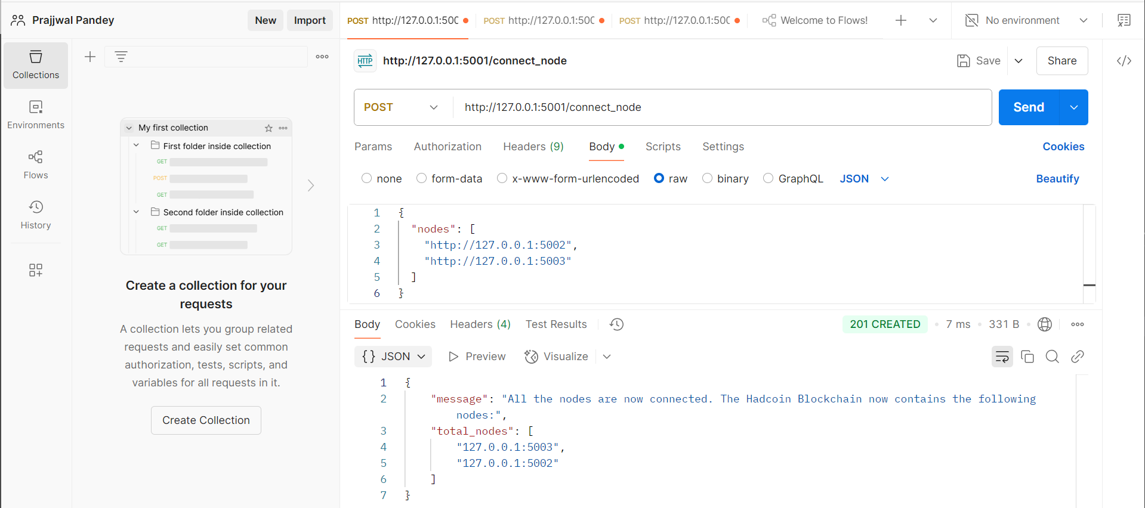

Node 2 -> 1,3
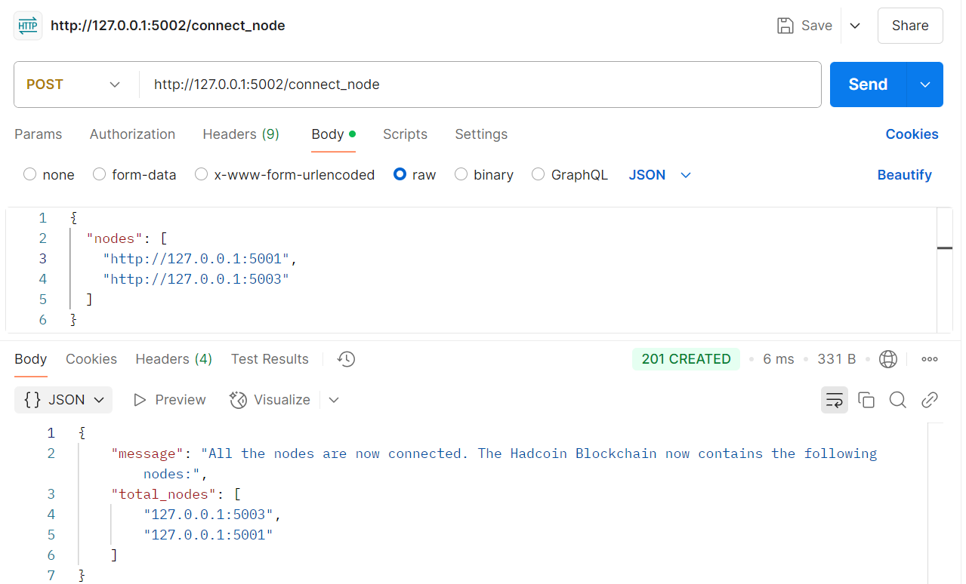

Node 3 -> 1,2
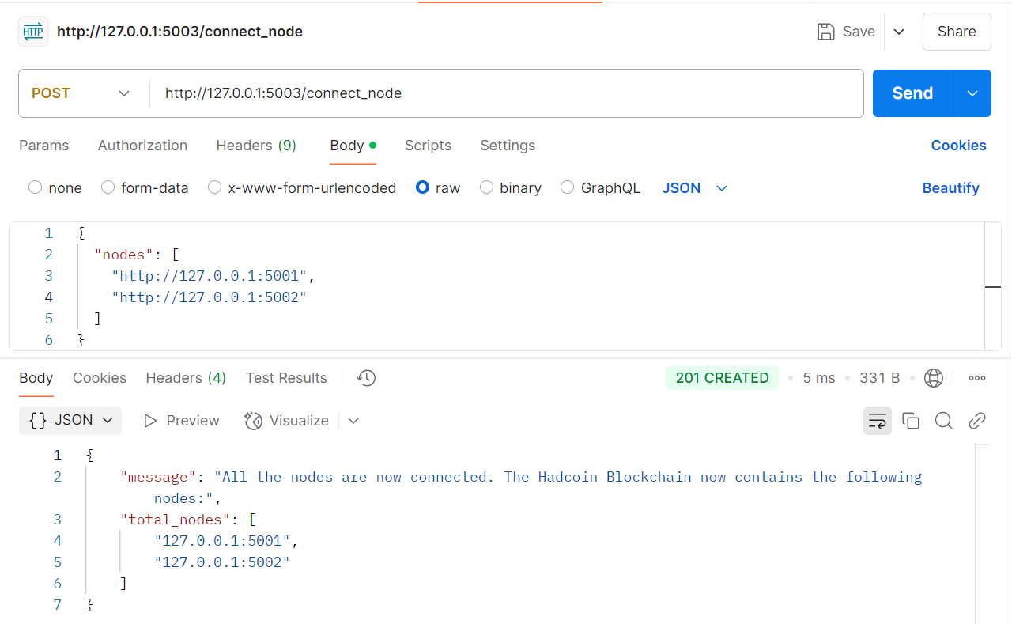

- Adding transaction from node 1
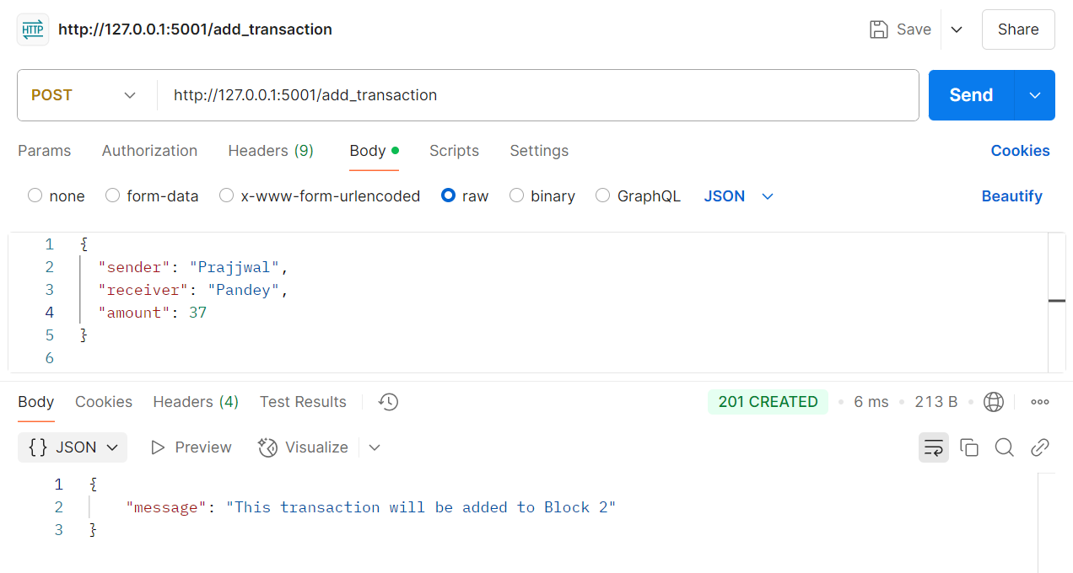

- Mining a Block (Only on 5001)
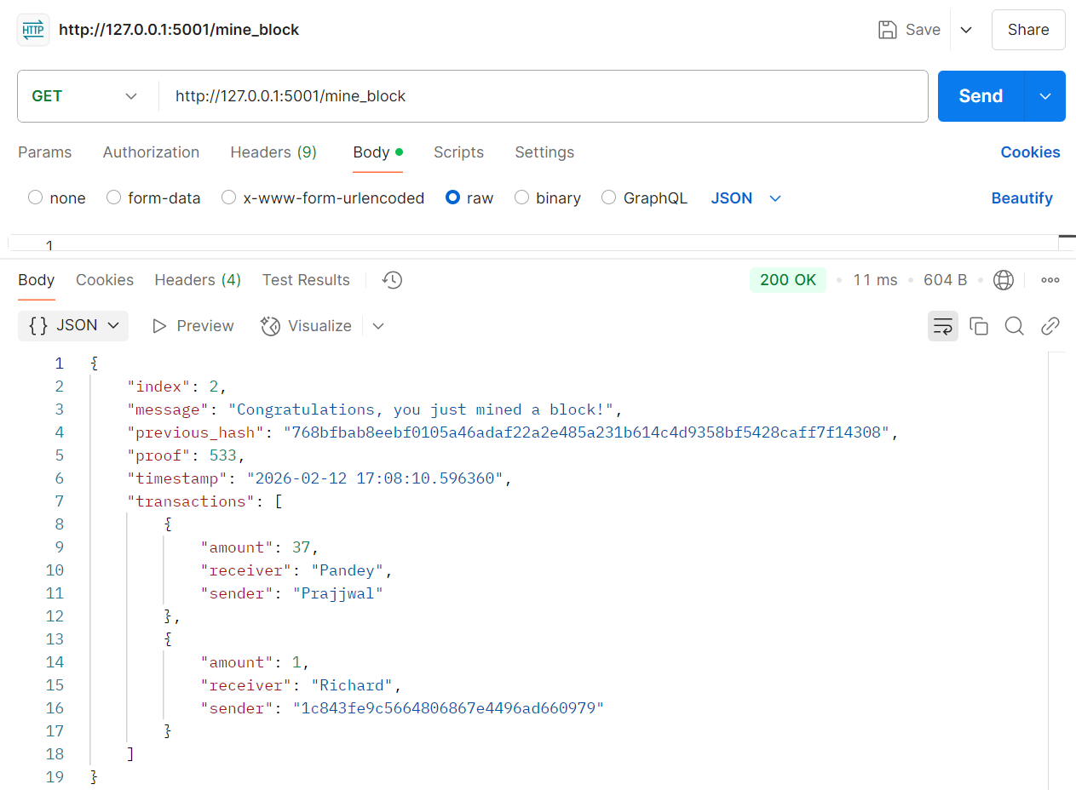

- Checking chain length difference: Node 1
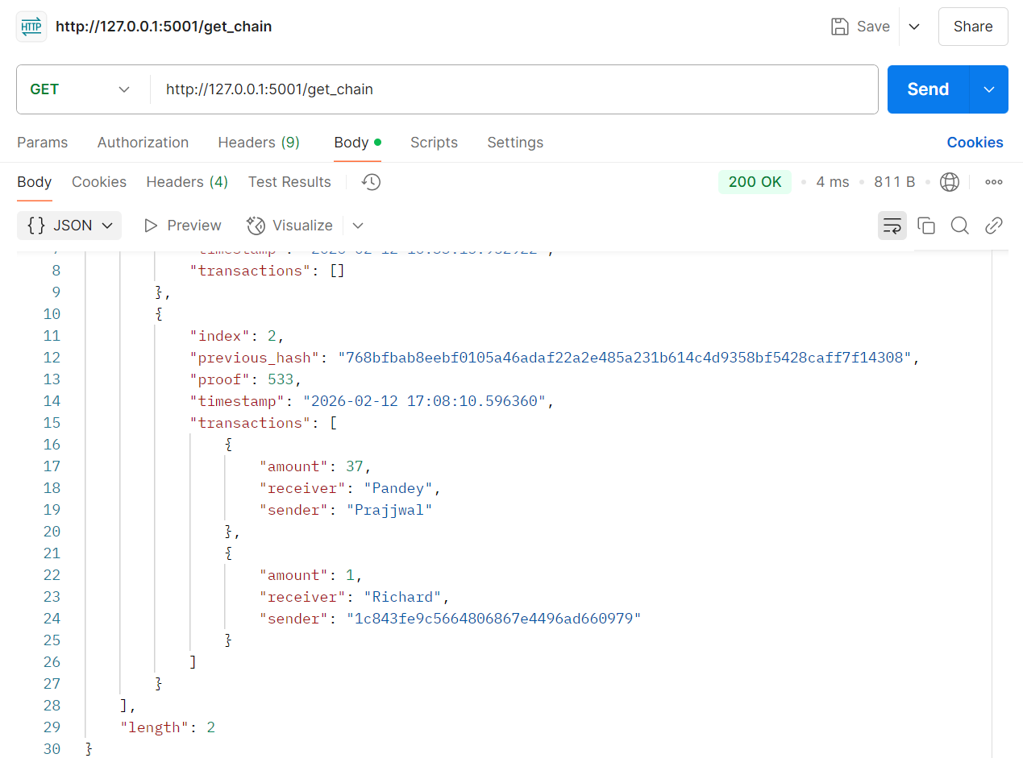

Node 2
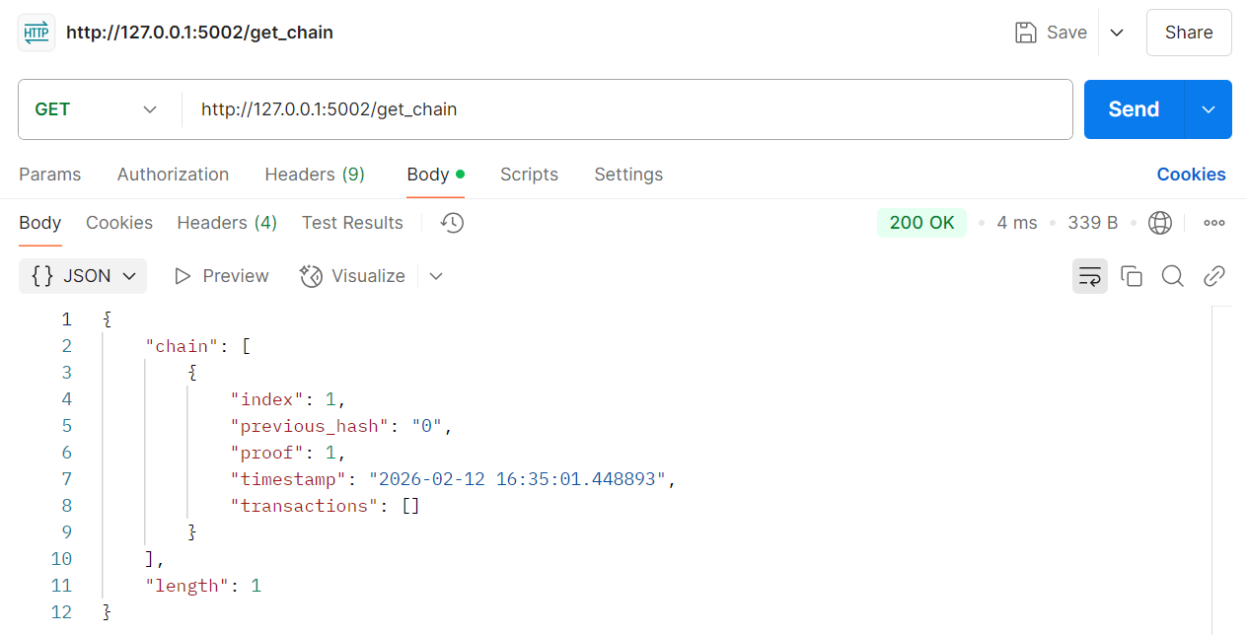

Node 3
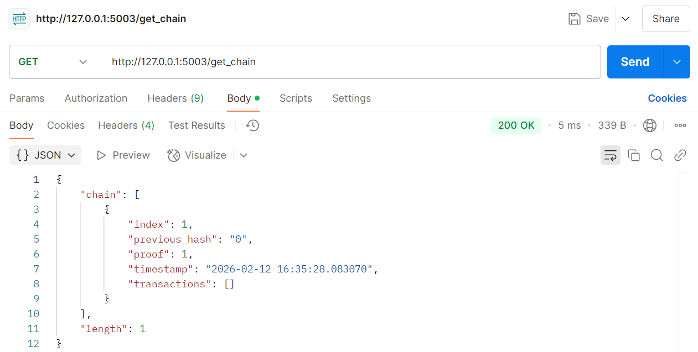

- Replace Chain (Consensus Mechanism) : Node 2
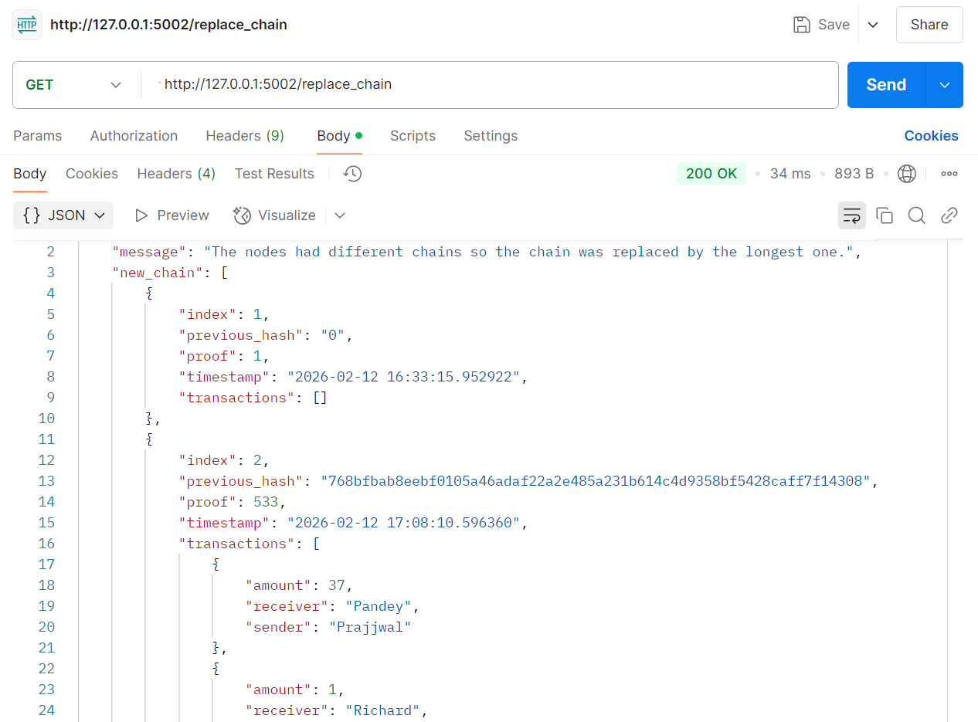

Node 3
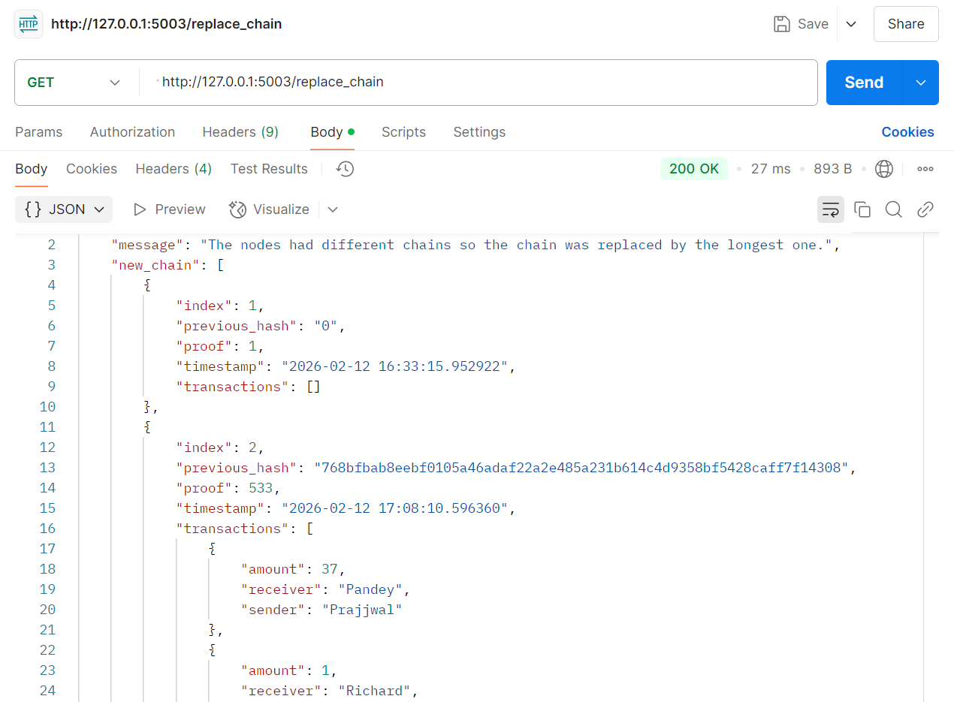
- Final Validation
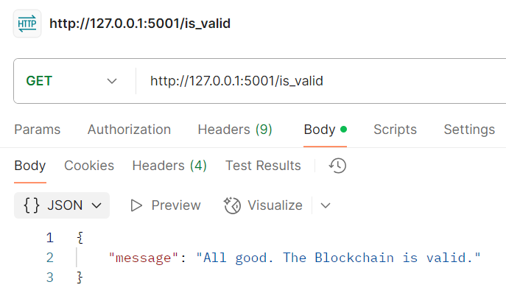

- Terminal Activity
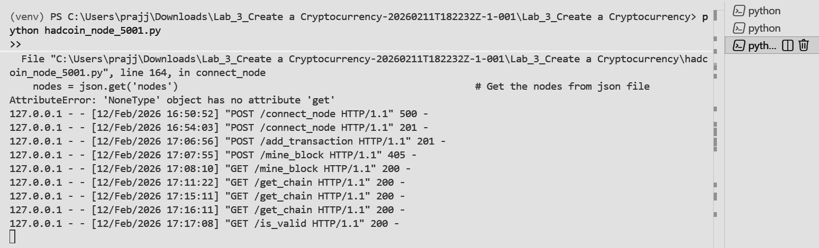

Conclusion: In this experiment, we successfully created a basic cryptocurrency using Python and Flask and implemented mining in a multi-node blockchain network. We demonstrated how transactions are added, stored temporarily, and included in a block during the mining process using a Proof-of-Work mechanism. By running three separate nodes, we simulated a peer-to-peer network and applied the Longest Chain Rule to maintain consensus across all nodes. The experiment helped us understand blockchain structure, decentralized networking, mining rewards, and chain synchronization in a practical manner.

